**Due at our Sunday, Feb 26, 2023 @ 7:00 pm (to discuss at team meeting)**

**Name:** Katie

* Remove FK from the conceptual model entity
* Change the word “PK” in the conceptual model to “Identifier”
  + Example:

Patients:

● PatientID - Identifier

● FirstName

● LastName

● DOB

● Gender

● DateAdmitted

● City

● State

● Country

● ZipCode

● InsuranceName

~~● DoctorID - FK~~

~~● NurseID - FK~~

~~● RoomID - FK~~

**Name:**

* Remove all FKs from the entire ERD diagram
  + Example:

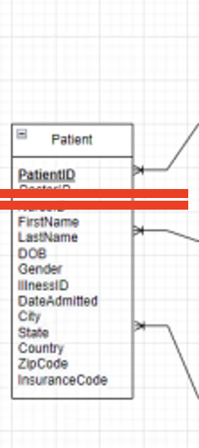

**Names: Bishoy , Vishnu**

* Create an improved switchboard. They layout should be:
  + Main Switchboard that have tabs to 4 sub switchboards
  + How this will look:

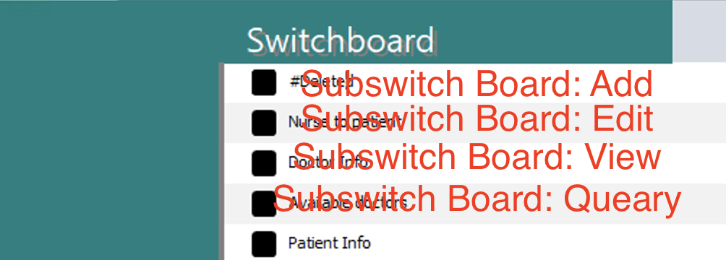

* + - SubSwitch Board #1: View Hospital Information (the switchboard we currently have)
    - SubSwitch Board #2: Adding

Want to be able to add columns to the patient, doctor, etc. databases 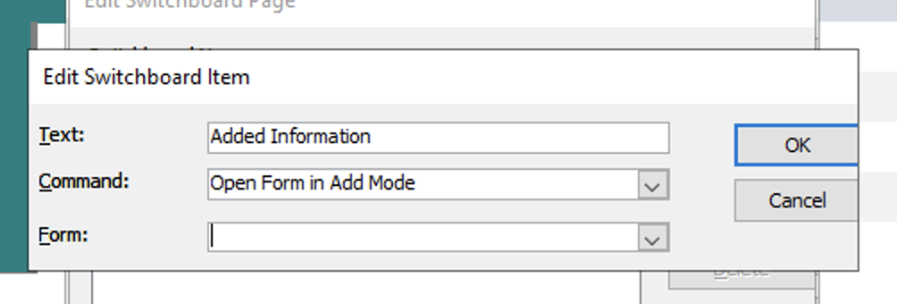

* + - SubSwitch Board #2: Edit

Same exact thing as SubSwitch Board #2: Adding but just use the “Edit Mode”. We want this in case a doctor gets fired

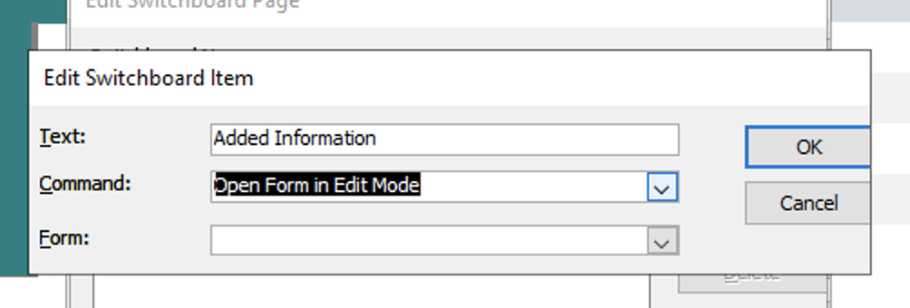

* + - SubSwitch Board #3: Query

We want to be able to open each of our 10 queries in the switchboard

Look at Class 11 module for details

You want to use his “Run Macro” equation

Also in the book under AC 10-4

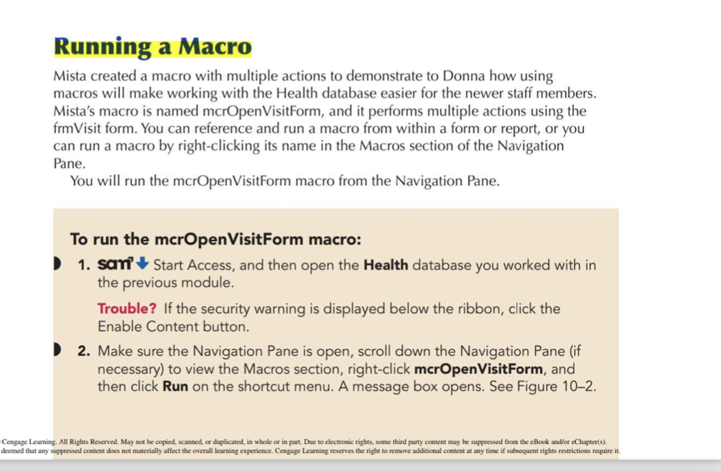

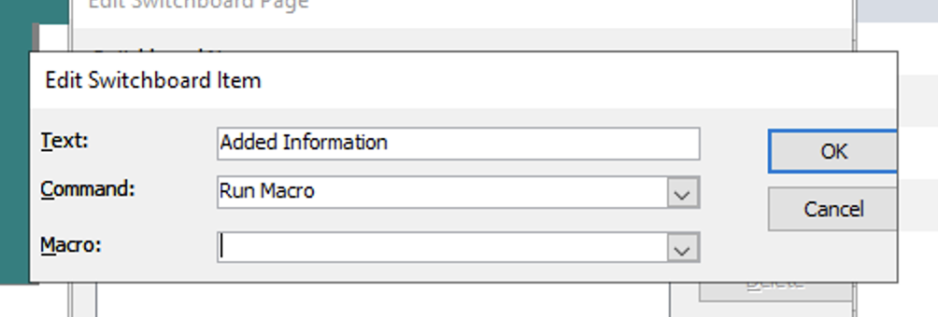

**Name:**

* Create a “Under Guide” on how to use the Access file
  + He said MOSTLY focus how how to use switchboard
  + This is SEPERATE from our final report / presentation
  + Should be short
  + Explains why we have each subform, what u can do with the switchboard, etc.
  + From project rubric:

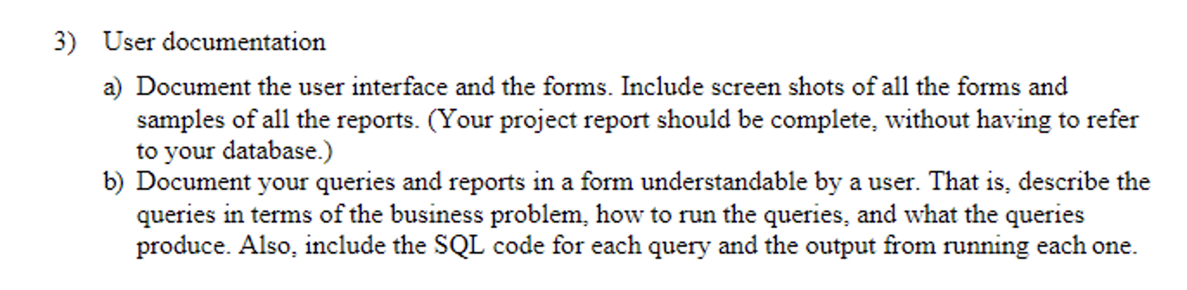

**Name:** Katie Kateyn and Ali have almost finished this

* Final report & Report
  + Look at project rubric for what needs to be included